Project Design Phase-II
Data Flow Diagram & User Stories

Date | 19-02-2026
Team ID | LTVIP2026TMIDS66350
Project Name | Calculating family expenses
Maximum Marks | 4 Marks

Data Flow Diagrams:
A Data Flow Diagram (DFD) for the Family Expense Management System illustrates how data moves through the system to record, process, and report family expenses efficiently. The process begins when a family member enters expense details such as date, amount, category, and description into the system. This input data is validated and stored in the central database, where expenses from all family members are consolidated. The system then processes the stored data to calculate totals, categorize spending, and update daily or monthly summaries. Administrators or the head of the family can retrieve this processed information in the form of reports, dashboards, or summaries to monitor financial status and budgeting. Additionally, the system may allow updates or corrections to previously entered data, ensuring accuracy over time. Overall, the DFD highlights how user inputs are transformed into meaningful financial insights through structured data storage, processing, and output generation, enabling better financial planning and decision-making for the family.

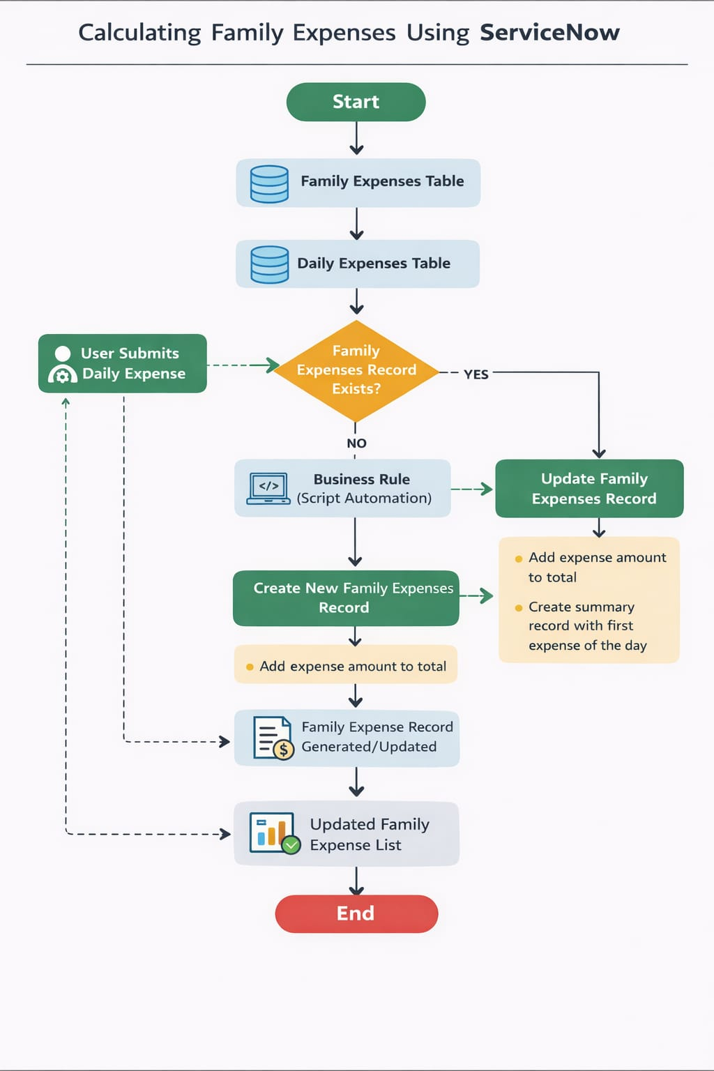

User Stories
Use the below template to list all the user stories for the product.
User Type | Functional Requirement (Epic) | User Story Number | User Story / Task | Acceptance Criteria | Priority | Release
Family Member | Expense Entry | USN-1 | As a family member, I want to record my daily expenses so they are tracked properly. | User can enter date, amount, category, and description successfully. | High | Sprint-1
Family Member | Expense Viewing | USN-2 | As a family member, I want to view my recorded expenses so I know my spending history. | System displays list of expenses by date with details. | High | Sprint-1
Head of Family | Budget Monitoring | USN-3 | As the head of the family, I want to monitor total family spending to stay within budget. | Dashboard shows total expenses for selected period. | High | Sprint-1
Head of Family | Expense Reports | USN-4 | As the head of the family, I want to generate monthly reports to analyze spending patterns. | System generates downloadable monthly summary report. | Medium | Sprint-2
Family Member | Expense Categorization | USN-5 | As a user, I want to categorize expenses (food, bills, travel, etc.) for better analysis. | User can select category while entering expense. | Medium | Sprint-1
Admin / Parent | Member Tracking | USN-6 | As a parent, I want to track expenses by each family member to understand spending habits. | Reports show expenses grouped by member name. | High | Sprint-2
Family Member | Edit/Delete Expenses | USN-7 | As a user, I want to update or delete incorrect expense entries. | User can edit or remove existing records. | Medium | Sprint-2
Head of Family | Alerts & Notifications | USN-8 | As a user, I want alerts when spending exceeds budget limits. | System sends notification when threshold is crossed. | Medium | Sprint-3
Admin | Data Management | USN-9 | As an admin, I want to maintain all expense records securely. | Only authorized users can modify or delete records. | High | Sprint-2
Family Member | Real-time Tracking | USN-10 | As a user, I want real-time updates of total expenses after each entry. | Total amount updates immediately after saving expense. | High | Sprint-1
Head of Family | Financial Insights | USN-11 | As a user, I want visual charts of spending trends for better decisions. | Dashboard displays graphs by category and time. | Medium | Sprint-3
Admin | System Configuration | USN-12 | As an admin, I want to configure categories and system settings. | Admin can add/edit/delete expense categories. | Low | Sprint-3

